Topics
- Windows | Mac | Linux (Or) Use directly on web browser
- What is Postman
- Start Postman | Signup | Setup
- Understand GUI
- How to add API Request?
- Run and check Response
- GET Request
- POST Request
- PUT & PATCH Request
- DELETE Request
- Collections
- Variables
- Environment
- Scripts
- Tests

What is Postman
Postman is a platform for API
- Development
- Testing
- Management

Step 1 Goto Postman website https://www.postman.com/
Step 2 Create Account | Check Email and verify account
Step 3 Can download Postman OR use Postman on web browser
Step 4 Login to Postman
Step 5 Explore GUI and features

How to add API Request?
Run and check Response
Step 1 Select the HTTP Method
Step 2 Add the API endpoint
Step 3 Add Headers, Authorizations etc as needed
Step 4 For POST, PUT requests add Body
Step 5 Save & Run, Check response

Sample APIs for Testing (sample api for testing)
https://regres.in/
https://httpbin.org/
https://fakerestapi.azurewebsites.net/
https://dummy.restapiexample.com/

How to Create and Run POST API Request
Step 1 Create a new HTTP Request
Step 2 Select the HTTP Method POST
Step 3 Add the API endpoint
Step 4 Add Headers, Authorizations etc. as needed
Step 5 For POST requests add Body
Step 6 Save & Run, Check response

https://www.w3schools.com/tags/ref_httpmethods.asp
https://www.contrive.mobi/aviorapi/HTTPMETHODS.html

Creating and Running PUT & PATCH API Request
Step 1 Create a new HTTP Request
Step 2 Select the HTTP Method
- PUT for replacing the complete resource
- PATCH for partially updating the resource
Step 3 Add the API endpoint
Step 4 Add Headers, Authorizations etc. as needed
Step 5 Add Body as needed
Step 6 Save & Run, Check response

Creating and Running DELETE API Request
Step 1 Create a new HTTP Request
Step 2 Select the HTTP Method DELETE
Step 3 Add the API endpoint
Step 4 Add Headers, Authorizations etc. as needed
Step 5 Save & Run, Check response

API COLLECTION
1. What is COLLECTION
2. How to create Collection
3. How to create folders inside collection
4. How to arrange requests inside collection
5. How to bring your Collection to the top
Step by Step from scratch
Collection is a group of API requests

Types of Variable in API
1. What are variables
2. Why and when to use variables
3. How to create variables
4. How to refer variables
Step by Step from scratch

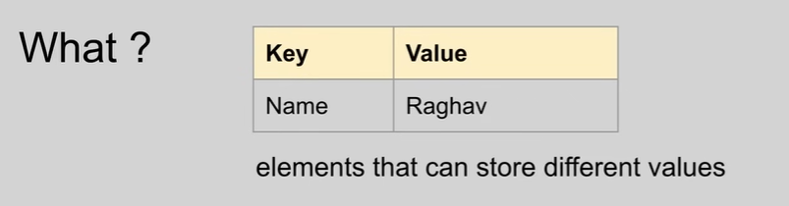
Ravikanth

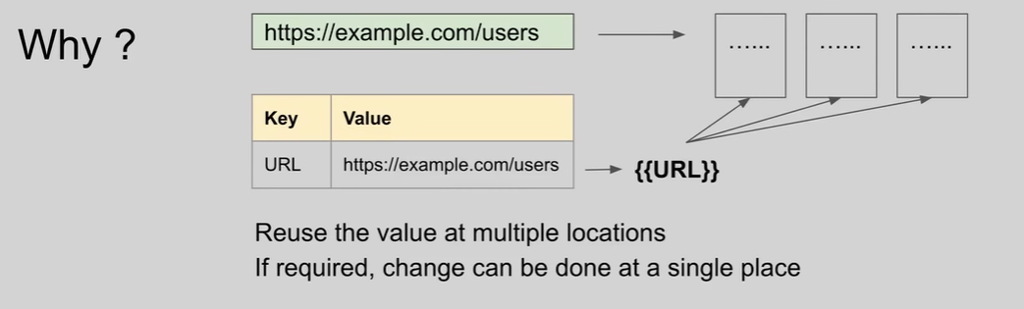

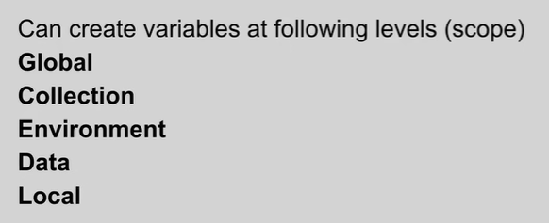

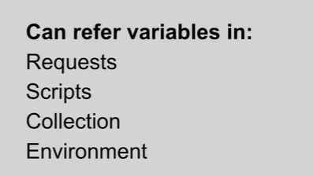

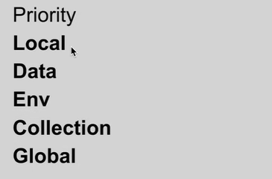

Topics
1. How to get variables through scripts
2. How to set variables through scripts

Postman - Get & Set variables with scripts
Set Variables with script
Global : pm.globals.set("name", "Edison");
Collection : pm.collectionVariables.set("name", "Newton");
Environment: pm.environment.set("name", "Rutherford");
Local : pm.variables.set("name", "Ramanujan");

Get Variables with script
Global: pm.globals.get("name");
Collection: pm.collectionVariables.get("name");
Environment: pm.environment.get("name");
Local: pm.variables.get("name");
**access a variable at any scope including local based on priority
To remove: pm.environment.unset("name");
To print variable value: console.log(pm.variables.get("name"));

Priority
Local
Data
Environment
Collection
Global

Topics
1. What is Environment
2. Why do we need Environments
3. How to create Environment
4. How to use Environment
5. How to delete Environment

Postman Environments
Environment is a set of key-value pairs
Step 1 - Create a api request
Step 2 - Create environments and add key-value pairs (variables)
Step 3 - Refer the variables in request
Step 4 - Select the environment from dropdown and run request
Step 5 - Create more environments and execute request

POSITIVE TEST SCENARIOS:

- Verify if 200 OK is received
- Verify if the response body contains some strings
- Verify if content-type response header is application/json

NEGATIVE TEST SCENARIOS:
- no auth
- invalid auth
- empty credentials
- invalid credentials
- http method tampering
- use IP address instead of domain name

This is a RESTful API that uses no auth

✅ POSITIVE TEST SCENARIOS
These are tests to confirm that the API behaves correctly under expected (valid) conditions.
- Verify if 200 OK is received
  - Confirms that the API call succeeds when valid inputs and authentication are provided.
  - Example: Send a GET request with valid headers and tokens, expect a 200 OK.
- Verify if the response body contains some strings
  - Checks whether specific expected data is present in the API response.
  - Example: Expect "status": "active" or "userId": 12345 in the response body.
- Verify if content-type response header is application/json
  - Ensures the response format is JSON, which is standard for REST APIs.
  - Why: Clients (like frontends) rely on this to correctly parse the response.

❌ NEGATIVE TEST SCENARIOS
These check the API's robustness by simulating improper or malicious use.
- No auth
  - Make a request without authentication headers.
  - Expected: 401 Unauthorized or 403 Forbidden.
- Invalid auth
  - Use a malformed or fake token.
  - Expected: 401 Unauthorized.
- Empty credentials
  - Send an auth header, but leave the token/username/password blank.
  - Expected: 401 Unauthorized or 400 Bad Request.
- Invalid credentials
  - Provide incorrect username/password or an expired token.
  - Expected: 401 Unauthorized.

- HTTP method tampering
  - Use the wrong HTTP method (e.g., POST instead of GET).
  - Expected: 405 Method Not Allowed or 400 Bad Request.
- Use IP address instead of domain name
  - Make the request to the server's IP instead of its domain.
  - Expected: May result in SSL/TLS errors or access denial, depending on server configuration.

